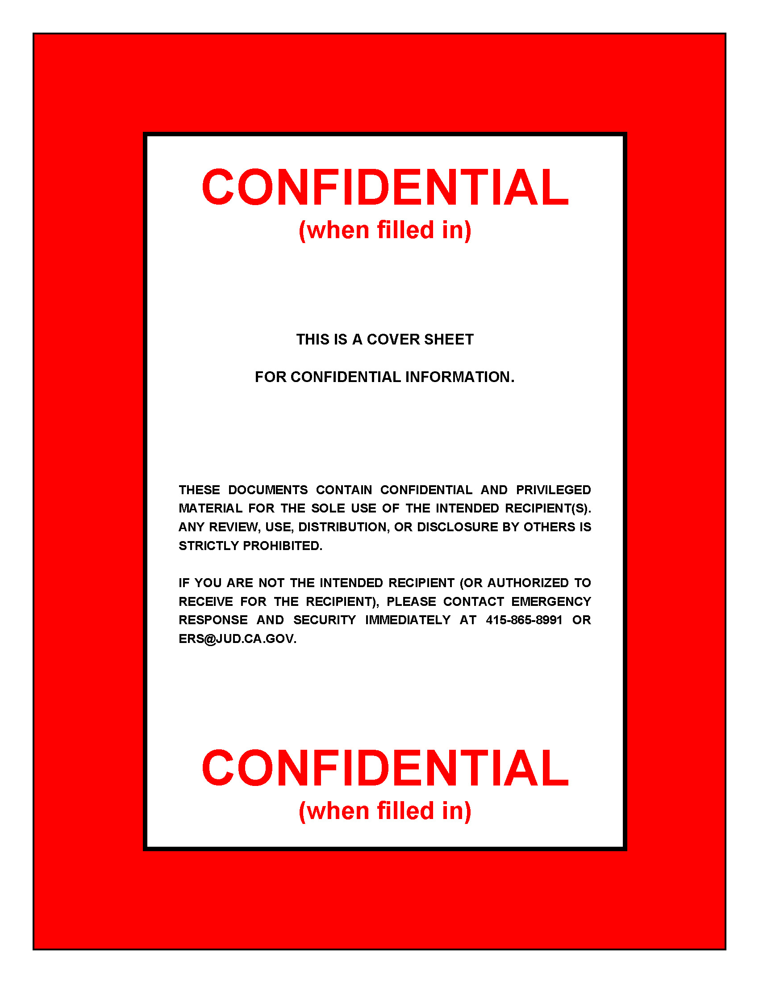
 |  | Home Security Assessment Checklist
 |  | date
 |  | 

PREFACE

The Home Security Assessment Checklist is designed to assist justices, judges, and other court officials in determining their level of security at home. The Checklist is a working document which can be used alone or in conjunction with a physical security survey by local law enforcement or Office of Emergency Response and Security (OERS) staff. The completed document should be considered confidential and secured at all times.

Individuals may not be able to complete every section. In some cases, certain sections may not apply; these should be marked as not applicable. Additionally, some areas may require in-depth technical knowledge and should be answered only if enough information is available to do so.

Although highly desirable, subjects marked “yes” on this checklist do not guarantee safety. Subjects marked “no” suggest that modifications should be considered.

To be most effective, security measures and procedures need to be discussed with all members of the household.

If you have any questions, please feel free to call OERS at 415-865-8991.
HOME SECURITY ASSESSMENT CHECKLIST

Facility Information
Home Address:
Date Completed:

Assessment Contact
Name and Title:
Phone:
E-mail:

Security Team Completing the Assessment
Member Name | Title and Office | Phone
1.
2.
3.
4.

Type of Assessment
Initial Assessment Follow-up Assessment
Self Assessment AOC Assessment

Brief description of the city or community where the home is located (e.g., population, main businesses, urban, suburban, rural, community highlights, etc.):

Home construction date:

Front Entrance | YES | NO
1. Is the door itself constructed of metal or solid wood?
2. Is the doorframe strong and tight enough to prevent forcing or spreading?
3. Are the door hinges protected from removal from the outside?
4. Are windows in or near the door more than 40 inches from the locks?
5. Is the door secured by a double-cylinder deadbolt lock with a minimum one-inch throw?
6. Is the door kept locked at all times?
7. Are strikes and strike plates properly installed with three-inch screws?
8. Does the door have an adequate viewer or intercom device?
9. Does the door or the area surrounding it have glass panels, which can be used to view visitors if a viewer or intercom is missing?
9. Are all visitors visually identified before unlocking and opening the door?
10. Is any mail slot, delivery port or pet entrance located so locks cannot be reached from the exterior?
11. Is there a screen or storm door with an adequate lock?
12. Is the exterior or front entrance lit with at least a 40-watt light?
13. Are landscaping and entryways designed and maintained to prohibit concealment of the front door?

Side or Rear Entrance | YES | NO
1. Is the door itself constructed of metal or solid wood?
2. Is the doorframe strong and tight enough to prevent forcing or spreading?
3. Are the door hinges protected from removal from the outside?
4. Are windows in or near the door more than 40 inches from the locks?
5. Is the door secured by a double-cylinder deadbolt lock with a minimum one-inch throw?
6. Is the door kept locked at all times?
7. Are strikes and strike plates properly installed with three-inch screws?
8. Is any mail slot, delivery port or pet entrance located so locks cannot be reached from the exterior?
9. Is the exterior or entrance lit by at least a 40-watt bulb?
10. Is the doorway concealed from the street or neighbors’ view (for example, by a porch, fence, or landscaping)?
11. Is there a screen or storm door with an adequate lock?
12. If the door is a sliding glass door, is the sliding panel secured to prevent someone from lifting it out of the track?
13. Is a security bar or key-operated lock used on the sliding glass door?

Entrances from Garage and Basement | YES | NO
1. Does the garage door have an automatic opener, so that drivers can enter and exit vehicles inside a closed garage?
2. Are all entrances to living quarters from garage and basement of metal or solid wood construction?
3. Does door from garage to living quarters have locks adequate for exterior entrance?
4. Does door from basement to living quarters have an adequate lock operated from living quarter’s side?

Ground Floor Windows | YES | NO
1. Do all of the windows have adequate, operational locks?
2. Are the windows kept locked at night and when away from home?
3. Do all of the windows have screens or storm windows that lock from the inside?
4. Are any windows that open onto areas that create a risk of burglary have security screens or bars?
5. Are the exterior areas of windows free from concealing structures and landscaping?
6. Is the exterior adequately lit at all window areas?

Upper Floor Windows | YES | NO
1. Are any of the upper floor windows that open onto the porch or garage roofs or the roofs of adjacent buildings have security screens or bars?
2. Are trees and shrubbery kept trimmed back from the upper floor windows, to permit good visibility around the house?
3. Are any ladders stored out of sight and in a location where they are not easily accessible?

Basement Doors and Windows | YES | NO
1. Is there a door from outside to the basement?
2. If so, is that door adequately secured for an exterior door?
3. Is the exterior basement entrance lit with at least a 40-watt light?
4. Is the exterior basement door visible from the street or neighbors’ view (for example, by a porch, fence, or landscaping)?
5. Are all of the basement windows sufficiently secured against entrance?

Garage Doors and Windows | YES | NO
1. Is the automobile garage door entrance equipped with an adequate locking device?
2. Is the garage door kept closed and locked at all times?
3. Are the garage windows secured sufficiently for ground floor windows?
4. Is the exterior utility entrance to the garage as secure as required for ground floor entrances?
5. Are tools, ladders, and other equipment stored in the garage?
6. Are all of the exterior garage doors lit with at least a 40-watt light?

Security Alarm System | YES | NO
1. Is the home equipped with a security alarm system?
If the answer to question 1 is yes, then complete questions 2–4.
If the answer is no, proceed to the next section of the document.
2. Is the alarm in good working order?
3. Is the alarm used regularly?
4. Does the alarm cover all doors and windows?
5. Are signs or window stickers applied indicating the presence of an alarm?

Perimeter Security | YES | NO
1. Is any perimeter fencing located on the property?
2. If so, is fencing located:
Rear yard?
Sides of house?
Front yard?
3. Does the property have motion activated exterior lighting?
4. Is landscaping maintained to prevent creating places of concealment?

Weapons
The decision whether or not to own a firearm is both personal and important. If firearm(s) are located in the home, it is important that every authorized user of the weapon(s) be familiar with and proficient in its operation. A firearms training course is highly recommended for all users. It is extremely important that all firearms be stored in a manner that will prevent unauthorized access to or use of the weapon(s).

Additional Security Measures
Standard security measures that can be taken with little cost or effort include restricting the number of keys to the home and changing locks if keys are ever lost or stolen. Never hide keys outside, and ensure that gates are locked and fences or walls are in good condition. Consider posting signs that may discourage intruders (for example, “member of neighborhood watch” or “house equipped with alarm system”). It is also a good practice to participate in neighborhood watch program. Be familiar with neighbors and know their vehicles. Pay attention to any suspicious vehicles and if appropriate, notify the police of the driver’s description and license plate number.

Robust security measures may include complete perimeter fencing, external surveillance cameras, motion activated lighting, and dogs. Interior “safe” rooms, equipped with exterior quality doors and locks may also be considered, and should be equipped with emergency items such as a cell phone, water, flashlight, and fire extinguisher.

Describe the additional security measures that are in place or may be considered.

ADDITIONAL SECURITY CONCERNS/ISSUES
Describe any additional security concerns or issues, or expand on any responses.

Resources
Share additional resources with judicial officers and family members as appropriate.

- Personal Security for Judicial Officers—OERS brochure outlining tips for personal security at home and while traveling. This brochure also covers threats, inappropriate communications, and handling mail safely.
- Travel Safely, Travel Securely—OERS brochure providing tips and information for home security while one is away, as well as personal security while en route, in hotels and motels, while driving, and at your destination.
- Privacy Protection Guidance—OERS guidance document that shares information about how online data vendors obtain information such as home address and telephone number, as well as how that information can be removed.

For copies, e-mail oers@jud.ca.gov or visit http://serranus.courtinfo.ca.gov/programs/security.

